HTML color 2

**Table of content**

* Explain RGB color?
* Explain HEX color?
* Explain HSL color?

**Explain RGB and RGBA color?**

**RGB-(red, green, blue)**

RGB color is a combination of three color that is red, green and blue. RGB colors are generally represented by rgb (red, green, blue). Rgb color has standard color set value which is use to represent the proper intensity of a color. The color in the RGB consists of fixed value range between ( 0 to 255 ). In this 0 represents less intensity of color and 255 represents high intensity of color

rgb (255, 0, 0)- This value represents red color.

rgb (0, 255, 0)- This value represents green color.

rgb (0, 0, 255)- This value represents blue color.

rgb(0, 0, 0)- This value represents black color.

rgb(255, 255, 255)- This value represents white color.

**RGBA-(red, green, blue, alpha)**

To represent the opacity of a color high or low alpha color is use. The range which shows the transparency of a color is (0.0 to 1.0). In this 0.0 represents opacity which is having very high transparency. 1.0 represents the solid color means very low transparency.

**Example- (RGB)**

<!DOCTYPE html>

<html lang="en">

  <head>

    <meta charset="UTF-8" />

    <title>Document</title>

  </head>

  <body>

    <h1

      style="

        color: rgb(77, 77, 224);

        background-color: rgb(241, 236, 212);

        text-align: center;

      "

    >

      Example of rgb color

    </h1>

    <h1 style="text-align: center; color: rgb(16, 207, 207)">

      rgb (red, green, blue).

    </h1>

    <p style="color: rgb(31, 9, 9);background-color: rgb(216, 211, 211);">

      RGB color is a combination of three color that is red, green and blue. RGB

      colors are generally represented by rgb (red, green, blue). Rgb color has

      standard color set value which is use to represent the proper intensity of

      a color. The color in the RGB consists of fixed value range between ( 0 to

      255 ). this 0 represents less intensity of color and 255 represents high

      intensity of color

    </p>

  </body>

</html>

**Output-**

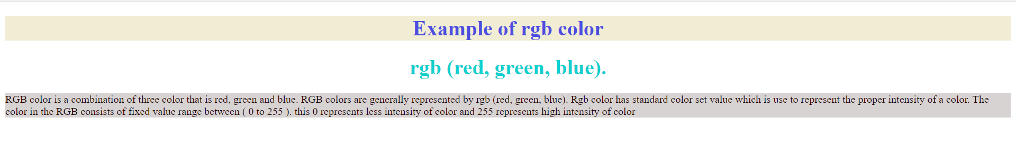

**Example-( RGBA) opacity**

<!DOCTYPE html>

<html lang="en">

  <head>

    <meta charset="UTF-8" />

    <title>Document</title>

  </head>

  <body>

      <h1 style="background-color: rgb(20, 5, 5); opacity: 0.1;color: rgb(138, 130, 130);">Example of opacity </h1>

      <h1 style="background-color: rgb(20, 5, 5); opacity: 0.2;color: rgb(100, 97, 97);">Example of opacity</h1>

      <h1 style="background-color: rgb(20, 5, 5); opacity: 0.3;color: rgb(148, 144, 144);">Example of opacity</h1>

      <h1 style="background-color: rgb(20, 5, 5); opacity: 0.5;color: rgb(153, 145, 145);">Example of opacity</h1>

      <h1 style="background-color: rgb(20, 5, 5); opacity: 0.8; color: rgb(214, 214, 218);">Example of opacity</h1>

      <h1 style="background-color: rgb(20, 5, 5); opacity: 1.0; color: rgb(245, 245, 248);">Example of opacity</h1>

  </body>

</html>

**Output-**

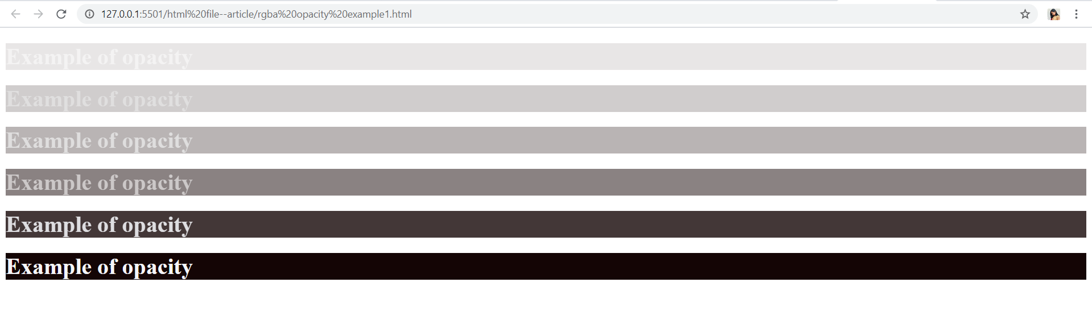

**Explain HEX color?**

HEX color is also a combination of basic colors that is red, green, blue color. HEX color can be written in the Hexadecimal format like #rrggbb. In this (rr) is use for representing red color. (gg) is for representing green color and (bb) is use for representing blue color. HEX color also consists of fixed color value range 00 to ff means color from 0 to 255.

#ff0000-This value represents red color.

#00ff00- This value represents green color.

#0000ff- This value represents blue color.

#000000- This value represents black color.

#ffffff- This value represents white color.

**Example-**

<!DOCTYPE html>

<html lang="en">

<head>

    <meta charset="UTF-8">

    <title>Document</title>

</head>

<body>

    <h1 style="text-align: center;">Example of HEX color</h1>

    <h2 style="background-color: #ff0000;">#ff0000-This value represents red color.</h2>

    <h3 style="background-color: #00ff00;">#00ff00- This value represents green color.</h3>

    <h4 style="background-color: #0000ff;">#0000ff- This value represents blue color.</h4>

    <h5 style="background-color: #000000;">#000000- This value represents black color.</h5>

    <h6 style="text-align: center;">Thank You</h6>

</body>

</html>

**Output-**

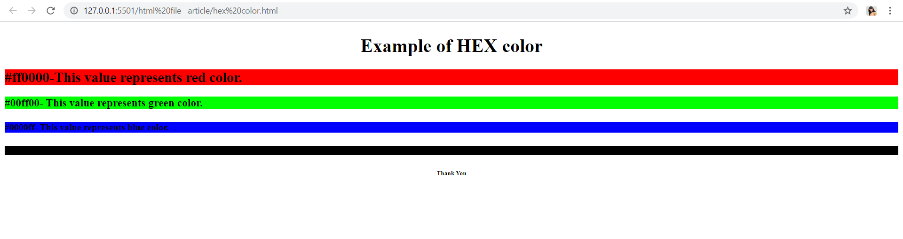

**Explain HSL color?**

HSL stands for HSL (hue, saturation, lightness).

Hue generally used to represents the color degree which starts from 0 to 360.

* 0 is use to represent red color
* 120 is use to represent green color
* 240 is use to represent blue color

Saturation is used to represent proper percentage of the color with saturation 0% to 100%.

Lightness is also represents the percentage value between 0 to 100 for representing 0% as a black shade and 100% as a white shade.

**Example- ( variation of saturation)**

<!DOCTYPE html>

<html lang="en">

<head>

    <meta charset="UTF-8">

    <title>Document</title>

</head>

<body>

    <h1>Example of HSL color with variations in saturation</h1>

    <h2 style="background-color: hsl(0, 100%, 50%); color:hsl(0, 100%, 90%) ;">HSL stands for HSL (hue, saturation, lightness). </h2>

    <h2 style="background-color: hsl(0, 80%, 50%);"> color represents 80% saturation</h2>

    <h2 style="background-color: hsl(0, 60%, 50%);"> color represents 60% saturation</h2>

    <h2 style="background-color: hsl(0, 40%, 50%);"> color represents 40% saturation</h2>

    <h2 style="background-color: hsl(0, 20%, 50%);">color represents 20% saturation</h2>

    <h2 style="background-color: hsl(0, 10%, 50%);"> Thanks</h2>

</body>

</html>

**Output-**

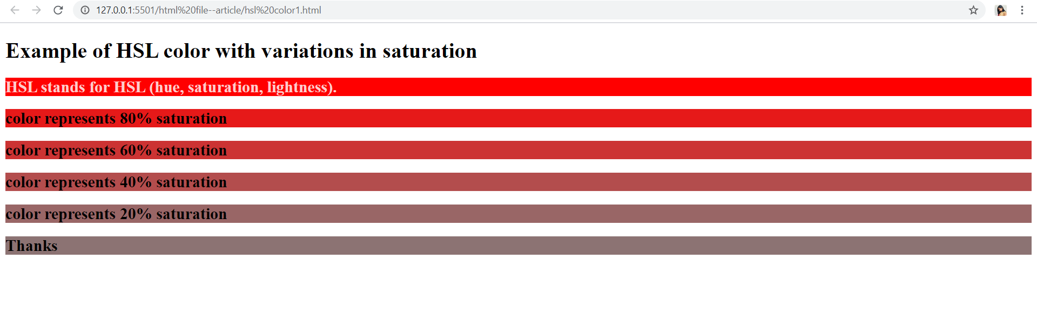

**Example- ( variation of lightness)**

<!DOCTYPE html>

<html lang="en">

<head>

    <meta charset="UTF-8">

    <title>Document</title>

</head>

<body>

    <h1>Example of HSL color with variations in lightness</h1>

    <h2 style="background-color: hsl(0, 100%, 0%); color:hsl(0, 100%, 90%) ;">HSL stands for HSL (hue, saturation, lightness). </h2>

    <h2 style="background-color: hsl(0, 100%, 25%);"> color represents 25% lightness</h2>

    <h2 style="background-color: hsl(0, 100%, 45%);"> color represents 45% lightness</h2>

    <h2 style="background-color: hsl(0, 100%, 50%);"> color represents 50% lightness</h2>

    <h2 style="background-color: hsl(0, 100%, 75%);">color represents 75% lightness</h2>

    <h2 style="background-color: hsl(0, 100%, 90%);"> Thanks</h2>

</body>

</html>

**Output-**

